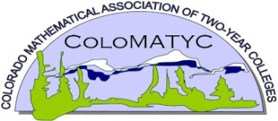
ColoMATYC
Registration Form
Due by Wednesday, March 9, 2022

Spring 2022 Virtual Conference held March 11, 2022
Return completed form via E-mail: Carol.Kuper@morgancc.edu
Save the Date: Registration will open February 25th

PART 1: PARTICIPATE INFORMATION

Name: |  | Institution:
Title:

Business Telephone Number: | E-Mail Address:

Part 2: Summary of Topics of Interest
Provide day-to-day teaching topics for inclusion into the Conference Program.

Thank you for your participation in ColoMATYC

