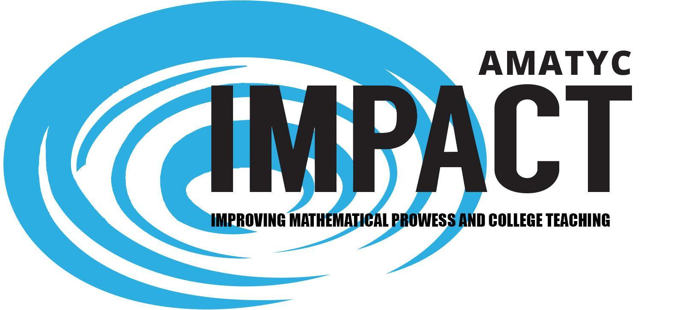

Request for Affiliate Endorsement by May 1, 2018
AMATYC IMPACT: Improving Mathematical Prowess And College Teaching

Submitted by Julie Phelps, Evan Evans, Mary Beth Orrange and Nancy Sattler

AMATYC IMPACT: Improving Mathematical Prowess And College Teaching is the new follow-up document to AMATYC's signature documents Crossroads in Mathematics and Beyond Crossroads. The goal of AMATYC IMPACT is to improve mathematics education in the first two years of college by presenting clear guidance of how to IMPACT the mathematical prowess of students. This guidance is meant to inspire faculty, departments, institutions, and policymakers to examine, assess, and take action to improve every component of mathematics education in the first two years of college. When the ideas of AMATYC IMPACT are implemented, students are empowered to be mathematically proficient and take ownership for their learning as they engage in the learning process. Faculty will facilitate student success in their chosen mathematical pathway with the support of their institutions.

AMATYC seeks to provide guidelines to inspire and challenge stakeholders to take action to develop PROWESS in students. There are four themes or pillars on which the document is based: PRoficiency, OWnership, Engagement, and Student Success. The pillars of PROWESS are an innovative way to enhance learning and college teaching in the first two years of college.

Technology has changed the way documents can be shared and modified in the 21st century. Although a printed copy of AMATYC IMPACT will be distributed at the Orlando meeting, the document will be online and will be enhanced based on best practices and current research. It will be a living document that will meet the needs of faculty teaching in the first two years of college.

The AMATYC Executive Board approved the philosophy and spirit of AMATYC IMPACT with the recommendation that the Delegate Assembly also endorse the document. The Delegate Assembly endorsed the philosophy and spirit of the document AMATYC IMPACT: Improving Mathematical Prowess and College Teaching at their meeting in San Diego. To submit your affiliate endorsement, by May 1, please click on the link: https://goo.gl/forms/Qjc2rS52rJeGgvlo2

Review process of AMATYC IMPACT
The draft of AMATYC IMPACT can be found at: www.amatyc.org/IMPACTFinalDraft
A two-part review process was established to receive input from the AMATYC community in general and a more directed process from targeted groups and individuals such as board members. The general review was housed on the AMATYC and the targeted review process was be housed on Google Drive. Input was collected until December 31, 2017. The document is in the process of being edited again to incorporate the feedback received during the open comment time. The document will be professionally edited and formatted with the addition of artwork, photos, etc. Data may be updated (for example with information from Conference Board of Mathematical Sciences 2015 survey) and citations will be confirmed. Wording and formatting may change, but the philosophy and spirit of the document in the link above will be accurately maintained.

Transition from Steering Committee to AMATYC Standards Committee
This document is the beginning of the work on the standards. AMATYC IMPACT will be presented as a living set of guidelines that will encourage adoption of the ideas aligned with AMATYC standards. The AMATYC Executive Board created a Standards Committee to oversee the evolution. The Standards Committee will be comprised of AMATYC members working on the marketing and promotion of the ideas in all three published AMATYC documents while developing a living portal that includes implementation specifics such as teaching ideas, department suggestions, and help for promotion of the standards beyond the classroom. The creation of the committee with a supported chair and a supported standards digital coordinator has ensured the continuation of the work started by the AMATYC IMPACT steering committee. The new committee began its work on January 1, 2018. The newest document is just the beginning!

Affiliate Endorsements and sharing of AMATYC IMPACT
This is a living project that will continue to develop through its digital products which will reflect this document. The AMATYC Standards Committee will continuously strive to keep the document up-to-date with current research and best practices. Endorsements from affiliates and other mathematical organizations are in progress. The conference roll-out of the AMATYC IMPACT document and the living document to be expanded on at the AMATYC IMPACT portal will take place at the 2018 conference in Orlando. Members attending the annual conference in Orlando will receive a paper copy of AMATYC IMPACT.

